Borrowing
Before borrowing publications from the Lending Department, readers have to order them from the Virtual Library (https://vb.lsu.lt).
The user shall pick up the books in person, upon presentation of an identity document.
The return deadline for borrowed publications is extended online, by logging in to the Virtual Library or by visiting Lending Department.
Instructions for ordering and renewal of books online can be found in the Library and on the Library website: https://www.lsu.lt/en/library/.
Use of computers
Computers shall be used to order publications and search for information needed for studies and research. Only university students and staff shall have access to computers.
Only university students and staff shall have access to the subscribed and tested databases. The subscribed electronic databases and full-text journal articles are accessible from home computers via EZproxy programme (https://www.lsu.lt/en/library/subscribed-databases-periodicals/).
Behaviour in the Library
Silence shall be maintained in the Library. Users shall switch off their mobile phones before entering the Reading Rooms. Smoking is forbidden in the Library. All readers shall follow the rules of conduct in a public place and online etiquette.
All graduating students shall return the borrowed items and settle all debts with the Library.
NOTE
In case a reader fails to return a borrowed item on time, he/ she will be charged a fee of 0.03 EUR per workday for one overdue item.
In case a reader damages or peels off a barcode on a book, he/ she shall be charged a fee of 1.45 EUR.
Services
Lending Department (1st floor)
Persons shall be granted a Reader’s Card upon presentation of a valid Lithuanian Student Identity Card or an identity card.
Educational literature can be borrowed for a period of one semester; scientific and fiction books can be borrowed for a period of three weeks.
Periodicals and the Internet Reading Room (2nd floor)
Lithuanian and foreign periodicals are stored and can be borrowed for use in the Reading Room.
The following services are provided: workplaces for work on computers, Internet access, wireless connection, SPSS programme; printing, scanning and copying; consultations on bibliographical entry issues; distribution of University publications.
Reading Room (3rd floor)
The most popular textbooks, scientific and information publications, doctoral dissertations and master's theses are stored and can be borrowed for use in the Reading Room.
The following services are provided: consultation on the use of databases; workplaces for work on computers, Internet access, wireless connection, SPSS and KINOVEA programme; copying, printing, scanning.

Rooms for group work (1st and 3rd floor)
The following services are provided: workplaces for work on computers, Internet access, wireless connection, multimedia, TV, SPSS programme; introductory training for first year students on information search issues (training schedule available).

For the convenience of readers with disabilities there is a lift, adapted sanitary facilities and a reading room (1st floor) with special eguipment adapted to their needs.



Opening hours

Monday to Thursday 8.00 - 19.00
Friday 8.00 – 17.00

Opening hours in July and August

Monday to Thursday 8.00 - 17.00
Friday 8.00 - 15.45
Lunch break 12.00 - 12.45

Opening hours may vary.
The day before the holiday the library is open a full hour shorter.
Address
Sporto St. 6, LT-44221 Kaunas

Tel. +370 690 09930

E-mail biblioteka@lsu.lt

In case you have problems with item renewal, contact us at skaitytojai@lsu.lt

Internet addresses
https://www.lsu.lt/en/library
https://www.lsu.lt/biblioteka https://www.facebook.com/LSU-Biblioteka-1029071727133357

LSU Virtual Library
https://vb.lsu.lt
Library information for LSU students shall be sent by e-mail

Registered readers have the right to:

- get detailed information about Library services and books.

- use library catalogues, databases and other information search tools.

- use Library computers and other equipment.

- borrow publications from the Library Repository for work at home or in the Reading Rooms.

- renew items via the Internet or at the Lending Department.

- order publications through interlibrary loan from other libraries in the country and abroad.

- submit a request orally, in writing, by telephone or e-mail.

We look forward to your suggestions!

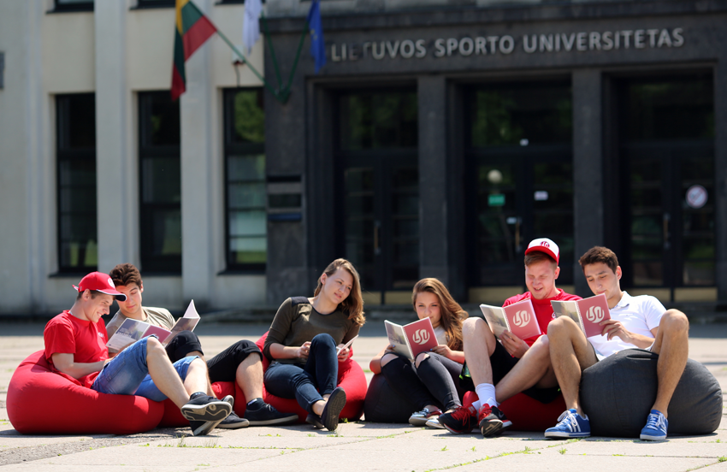

LIBRARY

Information for students

Kaunas 2025

