Seminar on Developmental Coordination Disorder (DCD)
Developmental Coordination Disorder is a relatively common (5-15% of each age cohort) developmental disability drawing upon disciplines associated with education, psychology and health. The term is used to describe a group of children who have difficulty with tasks involving movement such that it interferes with their daily living and academic progress. Although the condition has long been recognised as a motor coordination, control and learning problem, there remain challenging issues to be resolved related to its co-morbidity, assessment and intervention. The seminar gives insights into the diagnostics, mechanisms and multidisciplinary approaches to DCD.
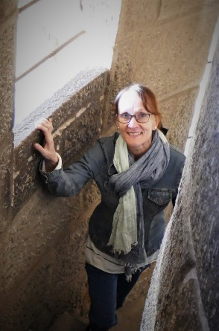

Dr. Marja Cantell studied physical education and psychology at the University of Jyväskylä, Finland and Lancaster University, UK. She also has a Graduate Diploma in Dance Movement Therapy (Roehampton University, UK) and a postdoctorate in Human Movement Science (U. of W. Australia). Dr. Cantell carries out multidisciplinary and mixed methods research in the fields of motor development and special needs children. During her position at the Department of Paediatrics, Alberta Children’s Hospital, Calgary, Canada, she received several grants to study determinants of physical activity in families with young children (“Y-Be-Active”). Since 2012, she has been back in Europe, working at the Inclusive and Special Needs Education Department at the University of Groningen. In 2017-24, her research team “MELLE”, carried out a follow-up study on motor, language and executive functioning in early childhood, extending to school readiness. In the same department, she coordinated the world’s only Master programme in Deafblindness. In her native country, Finland, where she is a Docent in Motor Learning, she has been involved in large research projects such as ‘the Skilled Kids’ study with researchers from the University of Jyväskylä, the Faculty of Sport and Health Sciences. She currently works at Codarts University of the Arts Rotterdam as research coach and research methods tutor for the Master’s in Arts Therapies programme, in particular, for students specialising in Dance Movement Therapy.

