UPLOADING MASTER THESIS

Go to eLABa website at: https://www.elaba.lt/elaba-portal/en/
Select a reference: Submit to repository
Select your institution: Lithuanian Sports University
Then sign in with your LSU single Sign-On account
Select New document: you will open a window for entering the data about your project

Common data: DB – select ETD
Type – Master thesis
The data will be entered in 5 steps.

Step 1: COMMON DATA

Document language: Lithuanian language is chosen automatically; please change the language if your document is in another language.
Scientific fields: enter at least one field and area of study which corresponds to the theme and problem of the thesis. If your thesis corresponds with more than one field and area, you can add it.
Select Scientific fields: + Add field of science / art.
Select Study fields: + Add study field.

SCIENTIFIC AND STUDY FIELDS:

PHYSIOTHERAPY (KIN):

M 001 | Natural, technological, medical and health, agricultural sciences > Medical and health sciences > Medicine | Scientific direction
M 005 | Natural, technological, medical and health, agricultural sciences > Medical and health sciences > Nursing | Scientific direction

G06 | Health sciences > Rehabilitation | Study direction

INTERNATIONAL BASKETBALL COACHING AND MANAGEMENT (KTV):

N 010 | Natural, technological, medical and health, agricultural sciences > Natural sciences > Biology | Scientific direction

R01 | Sport and exercise > Achievement sport | Study direction

INTERNATIONAL MASTER IN PERFORMANCE ANALYSIS OF SPORT (SVA):

N 010 | Natural, technological, medical and health, agricultural sciences > Natural sciences > Biology | Scientific direction

R01 | Sport and exercise > Achievement sport | Study direction

ADAPTED PHYSICAL ACTIVITY (TFV):
M 001 | Natural, technological, medical and health, agricultural sciences > Medical and health sciences > Medicine | Scientific direction
M 005 | Natural, technological, medical and health, agricultural sciences > Medical and health sciences > Nursing | Scientific direction

G06 | Health sciences > Rehabilitation | Study direction

SPORTS PHYSIOLOGY AND GENETICS (SFZ):
N 010 | Natural, technological, medical and health, agricultural sciences > Natural sciences > Biology | Scientific direction

D01 | Life sciences > Biology | Study direction

PHYSICAL ACTIVITY AND PUBLIC HEALTH (FAV):
M 004 | Natural, technological, medical and health, agricultural sciences > Medical and health sciences > Public health | Scientific direction

G04 | Health sciences > Public health | Study direction

TOURISM AND SPORTS MANAGEMENT (TSV):
S 003 | Humanities and social sciences > Social sciences > Management | Scientific direction
S 004 | Humanities and social sciences > Social sciences > Economics | Scientific direction

L02 | Business and management > Management studies | Study direction

If you mark the right criteria and confirm it by pressing the confirmation button, the criteria will be entered automatically.
Then press the button to Continue.

Step 2: TITLE, SUMMARY AND KEYWORDS

Title, annotation, and keywords should be written in English and in Lithuanian. The keywords written in the language of the document must come first.
Press the button: + Add and fill proper data.
Titles should be written in lowercase letters (except the first word and proper names).
Annotation – summary (lowercase).
Keywords should be written in lowercase letters, separated by semicolon.
Press the button to Confirm (the data will be saved) and Close.
Then press the button to Continue.

Step 3: PHYSICAL DATA

Scope: enter the number of pages in PDF file (e.g., 85 p.)
Thesis defense (Date of defense): enter the date of the defense of your project or select it from the calendar.
Other responsible persons: select supervisor by pressing the button: + Add responsible person; enter the last name of the supervisor to search the users’ list.
Description: Thesis Supervisor.
Press the button to Confirm and Continue.

Step 4: ATTACHED FILES

Press the button: + Select a file. Upload a PDF file of the thesis. Title pages, declaration of academic integrity, thesis and appendices must be a single PDF file.

Access status: specify access limitations for the uploaded file. You can select from:
Public – all uploaded files will be freely accessible by eLABa search system.
Limited to institution intranet – all uploaded files will be accessible by computers from LSU network. Unavailable – all uploaded files will be inaccessible by eLABa search system, only metadata will be accessible.

If you choose Limited to institution intranet or Inaccessible, a field Valid until will appear. You must specify expiry date of accessibility. After the expiry date (no more than 5 years), all uploaded files become freely accessible on the Internet. You must consult your supervisor about access limitations and expiry date.
Press the button to Continue.

Step 5: LICENSE AGREEMENT WITH AUTHOR

License type: Electronic.
Actions: select an action – Send to supervisor to confirm and press Save.

ACTIONS AFTER SUPERVISOR’S CHECK FOR PLAGIARISM

When supervisor has checked the thesis for plagiarism, student receives an e-mail message. If the e-mail message says that a License Agreement should be signed, login to the eLABa repository and at the bottom of the record License agreement with the author confirm that the data in the License Agreement is correct (pressing the checkbox inserts a check mark).

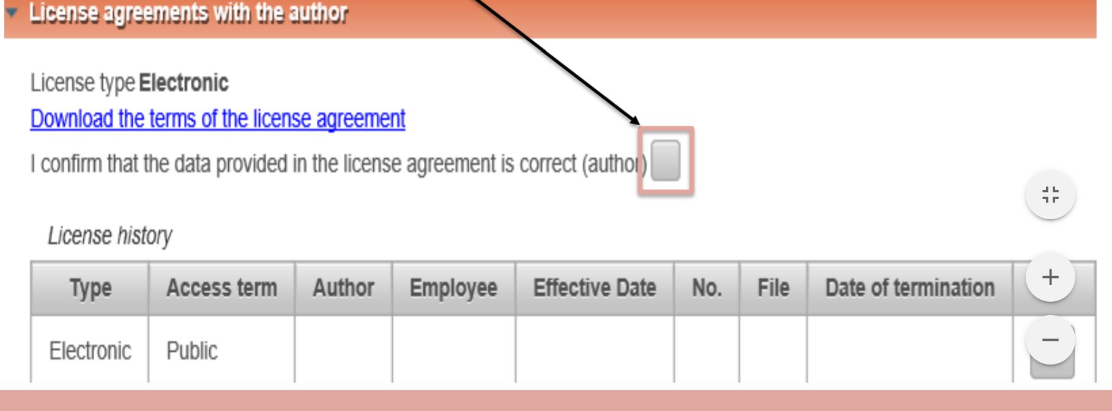

Then change the status of the thesis: Mark for defense and press Save.

