 | Nordic-Baltic Updated Coaching Development  NPHZ-2019/10042

Minutes from meeting held in March 7-9, 2022, Riga
PARTICIPATED:
Karsten Froberg University of Southern Denmark, Denmark
Inga Lukonaitiene Lithuanian Sports University, Lithuania
Kimmo Kantosalo Haaga-Helia University of Applied Sciences, Finland
Maiju Kokkonen The Sports Institute of Finland, Finland
Agita Abele Latvian University Sports Federation , Latvia
Justė Knatauskaitė Lithuanian Sports University, Lithuania

Online (via zoom):
Thomas Bredahl Viskum University of Southern Denmark, Denmark
Kristina Bradauskienė Lithuanian Sports University, Lithuania
Irena Čikotienė Lithuanian Sports University

The aims of the meeting were:

- General overview of the material in MOODLE system.
- Preparation of e-learning module manuscript.
- Other

- General overview of the material in MOODLE system.
The meeting days were constructed according to originally proposed programme (Annex 1). The meeting started with the overview of the project and tasks implemented before. Few questions were raised about created Moodle platform in the Lithuanian Sports University system. The whole group decided to use different tools for creating accessible module creating system to usen with any e-learning platforms. It was decided to build an interactive layout of the proposed module.

- Preparation of e-learning module manuscript.
Maiju Kokkonen and Kimmo Kantosalo proposed to use “Thinglink” tool to create the full manuscript of the module. The team were working on it throughout the rest of the day. The end product was “Thinglink” interactive module material together with google account for the shared material. (https://www.thinglink.com/scene/1557688134152486915). Annex 2.

- Other
The meeting of the whole group was arranged in a mixed mode, both with the people in Riga and the rest of the group online. The created module and it’s functions were presented to the partners participating online. It was decided that the missing material should be filled in each interactive folder within google drive. The preparation of final report was discussed. Also, the possibility to have final meetings online and face-to-face according to the original application, were suggested.

Decided:
- To create interactive module manuscript.
- The module manuscript was created (Annex 2).
- It was decided to meet online for the final revision and discussion about the possible face-to-face meeting and the report of the project.

Annex 1. The program of the meeting

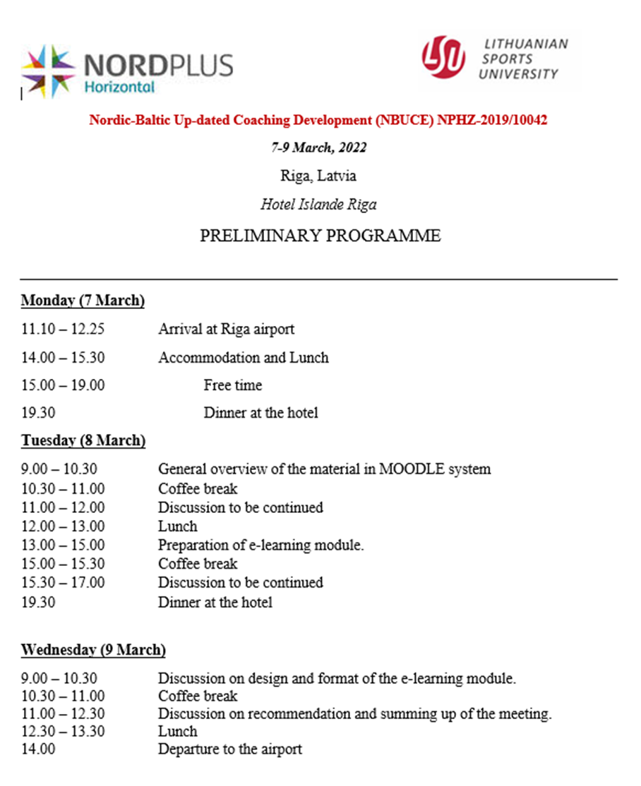

Annex 2.

