Project: 8.2.1.0/18/A/020

An innovative, research-based international interuniversity joint Doctoral study programme “Sport Science” by the Latvian Academy of Sport Education

The project objective is to reduce the fragmentation of study programmes and to strengthen the sharing of resources in the Latvian Academy of Sport Education by developing an innovative, research-based international interuniversity joint Doctoral study programme «Sport Science».

Total costs of the project: 100000,00 euro
funding from the European Social Fund – 85000,00 euro and
co-financing from the State budget – 15000,00 euro
Planned results of the project for the Latvian Academy of Sport Education are the following:
- One closed study programme “Sport Science” (51813), on the basis of which the supported new Doctoral study programme will be developed;
- One new joint Doctoral study programme, the development and implementation of which is supported by the European Social Fund and which has received accreditation by the EQUAR Agency.
Project implementation:
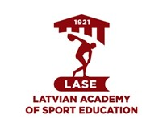 | LATVIAN ACADEMY OF SPORT EDUCATION
Partners:
 | Lithuanian Sports University
 | Józef Piłsudski University of Physical Education in Warsaw
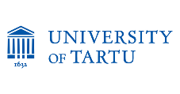 | University of Tartu

Estimated duration of project implementation: 01.05.2019.-31.10.2022.

