UPLOADING MASTER THESIS

Go to eLABa website at: https://www.elaba.lt/elaba-portal/en/
Select a reference: Submit to repository
Select your institution: Lithuanian Sports University
Then sign in with your LSU single Sign-On account
Select New document - you will open a window for entering the data about your project

Common data: DB – select ETD
Type – Master thesis
The data will be entered in 5 steps.

Step 1: COMMON DATA

Document language - Lithuanian language is filled automatically, please select, if your document is in another language.

Scientific fields - enter at least one field and area of studies which corresponds the theme and problem of thesis. If your thesis corresponds with more fields and areas, you can add them.
Select Scientific fields: + Add field of science / art.
Select Studies fields: + Add studies field

SCIENTIFIC AND STUDIES FIELDS:
Physiotherapy (KIN):
M 001 | Natural, technological, medical and health, agricultural sciences > Medical and health sciences > Medicine | Scientific direction
M 005 | Natural, technological, medical and health, agricultural sciences > Medical and health sciences > Nursing | Scientific direction

B300 | Biomedical sciences > Medicine and health > Rehabilitation | Studies direction
Basketball Coaching and Management (KTV):
N 010 | Natural, technological, medical and health, agricultural sciences > Natural sciences > Biology | Scientific direction

C600 | Biomedical sciences > Life sciences > Sport and exercise | Studies direction
Performance analysis of Sport (SVA):
N 010 | Natural, technological, medical and health, agricultural sciences > Natural sciences > Biology | Scientific direction

C600 | Biomedical sciences > Life sciences > Sport and exercise | Studies direction

If you mark the right criteria and press button, it will be entered automatically.
Then press the button Continue.

Step 2: TITLE, SUMMARY AND KEYWARDS

Title, annotation, keywords should be written in English and in Lithuanian (lowercase). Language in which document is written, must be the first.

Press the button: + Add and fill proper data.
Titles should be written in lowercase letters (except the first word and proper names).
Annotation – summary / santrauka.
Keywords should be written in lowercase letters, separated by semicolon.

Press the button Confirm (the data will be saved) and Close.
Then press the button Continue.

Step 3: PHYSICAL DATA

Scope - enter the number of pages in PDF file, e.g. 85 p.
Work defense:
Date of defense - enter or select from calendar defense date of your project.
Other responsible persons – select supervisor.
Press the button: + Add responsible person - enter the last name - make a search from users‘ list. Description - Thesis Supervisor and press Confirm.
Then press the button Continue.

Step 4: ATTACHED FILES

Press the button: + Select a file - upload a PDF file of the thesis. Title pages, declaration of academic integrity, thesis and appendixes must be a single PDF file.

Access status - specify access limitations for the uploaded file.

You can select:
Public- all uploaded files will be freely accessible by eLABa search system.
Limited to institution intranet - all uploaded files will be accessible by computers from LSU network. Unavailable - all uploaded files will be inaccessible by eLABa search system, only metadata will be accessible.

In case you choose Accessible only in the Intranet or Inaccessible, a field Valid until appears. You must specify expiry date of accessibility. After the expiry date (no more than 5 years), all uploaded files become freely accessible in the Internet. You must consult your supervisor about access limitations and expiry date.
Then press the button Continue.

Step 5: LICENSE AGREEMENT WITH AUTHOR

License type – select Electronic.
Actions: select an action - Send to supervisor to confirm and press Save.
ACTIONS AFTER SUPERVISOR’S CHECK FOR PLAGIARISM

When supervisor has checked the thesis for plagiarism, student receives an e-mail message. If the e-mail message says that a License Agreement should be signed - login to the eLABa repository and at the bottom of the record License agreement with the author confirm that the data in the License Agreement is correct (inserts a check mark).

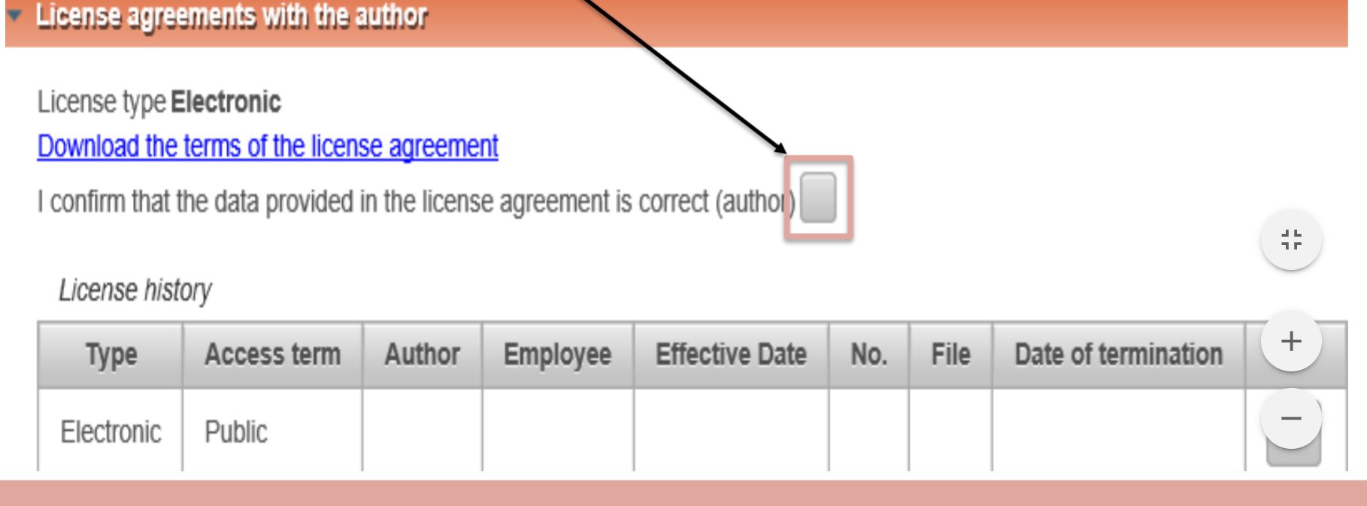

Then change the status of the thesis: Mark for defense and press Save.

